

|  |  |  |  |  |  |
| --- | --- | --- | --- | --- | --- |
| Programme | : | **M.Tech SE** | Semester | : | **Fall 20-21** |
| Course | : | **Advanced Database Management Systems (Embedded Lab)** | Code | : | **CSE2004** |
| Faculty | : | **Dr.Bhuvaneswari A** | Slot | : | **L43 + L44** |
| Ex. No. | : | **10** | Date | : | **20-10-2020** |

**KANDULA NAVEEN KUMAR**

**17MIS1056**

**XML**

**Use w3schools XML XPATH XQUERY online**

Preliminary References :

XPATH <https://www.w3schools.com/xml/xpath_examples.asp>

XML DTD: <https://www.w3schools.com/xml/xml_dtd_examples.asp>

XQUERY : <https://www.w3schools.com/xml/xquery_select.asp>

**LAB QUESTIONS**

**Part 1: Create a DTD**

Write a DTD that is valid with respect to the data in countries.xml file. The easiest way of doing it is to modify the countries.xml file to add and internal or external DTD (as discussed in class)

ANS:

<?xml version="1.0">

<!DOCTYPE countries[

<!ELEMENT countries(name,population*,area*,language+,percentage,city)>

<!ELEMENT name (#PCDATA)>

<!ELEMENT language (#CDATA)>

<!ELEMENT percentage (#CDATA)>

<!ELEMENT city (name,population*)>

<!ELEMENT name (#PCDATA)>

<!ELEMENT population (#CDATA)>

]>

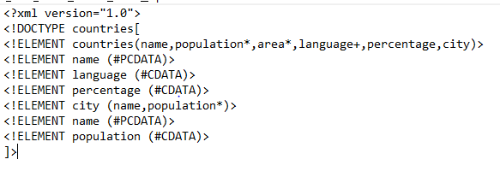

**Part 2: XPath**

  Online Link : <http://xpather.com/9WTX6zD7>

Write XPath queries to answer the following questions (one query for each question below). Execute the XPath queries using XML online tool to ensure you get the correct answer.

1. Return the languages used in Switzerland.

ANS:

//country[@name="Switzerland"]/language

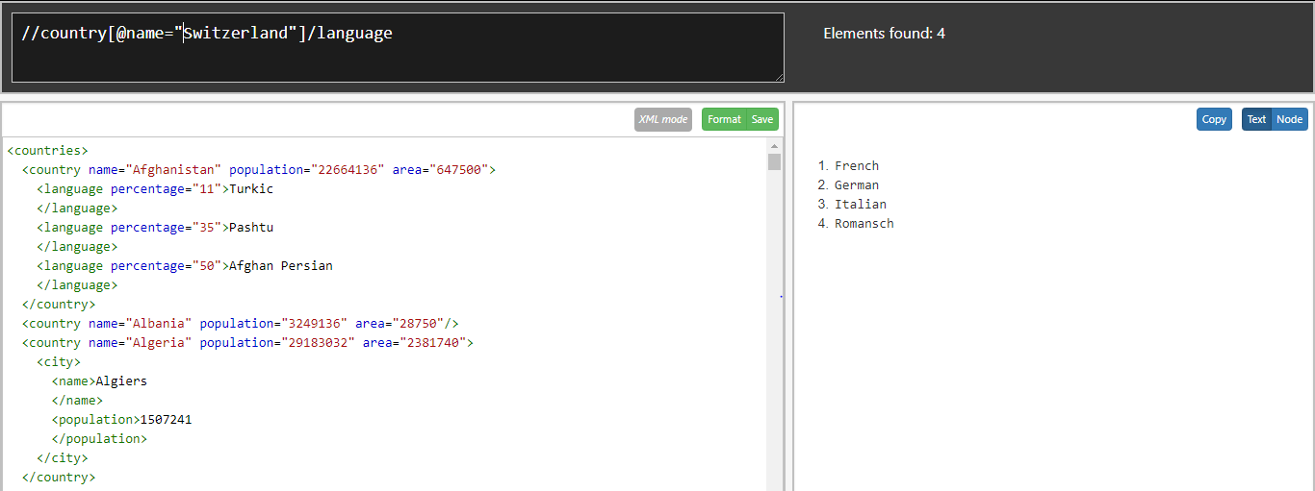

1. Return the area of Mongolia.

ANS:

//country[@name="Mongolia"]/@area

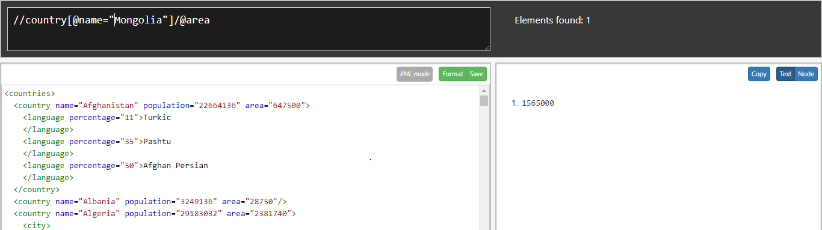

1. Return the names of all countries with population greater than 100 million.

ANS:

//country[@population>100000000]/@name

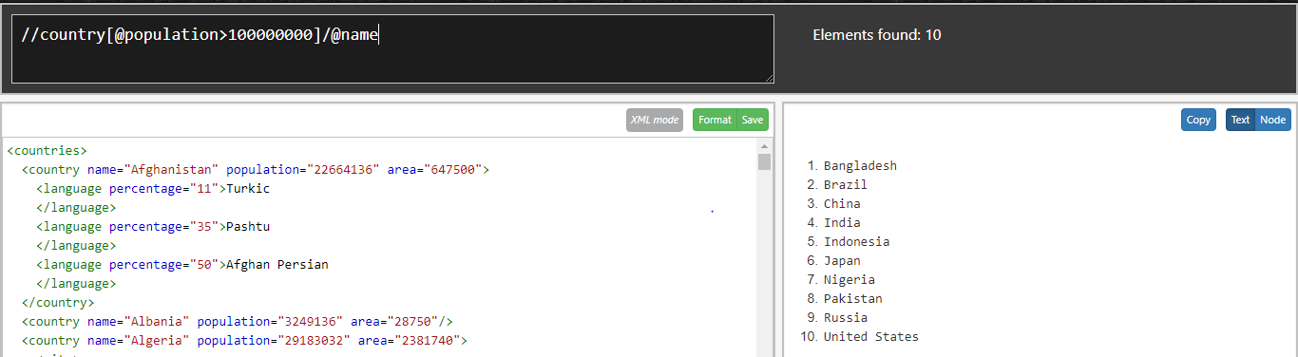

1. Return the number of countries where Russian is spoken.

ANS:

//country[language[text() ="Russian"]]/@name

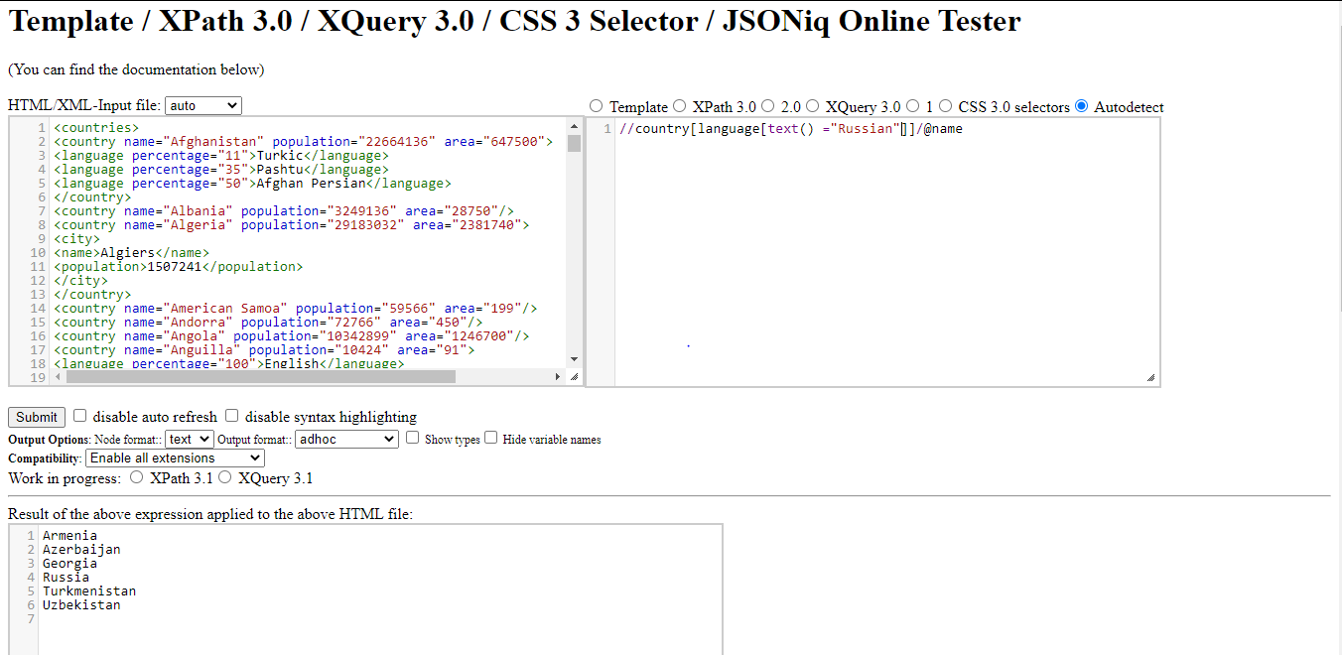

1. Return the names of all countries where over 50% of the population speaks German.

ANS:

//country[language[text()="German"][@percentage>50]]/@name

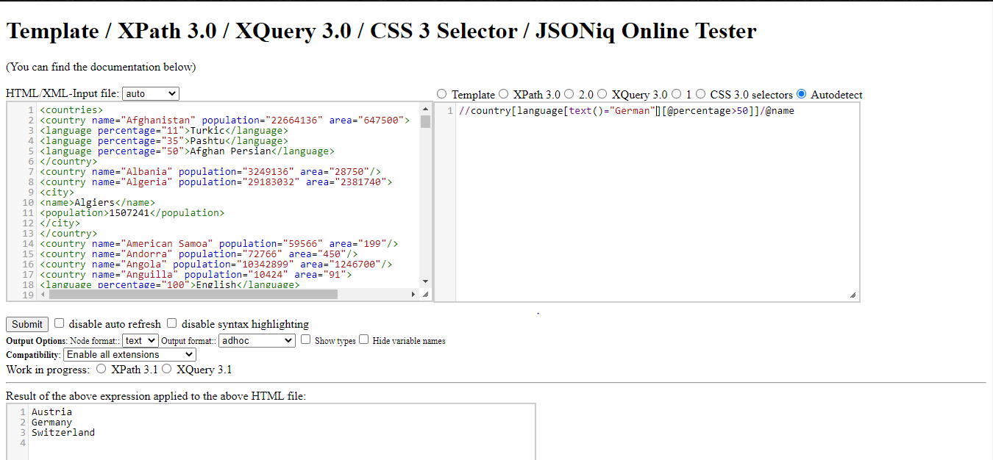

**Part 3: XQuery**

Write XQuery queries to answer the following questions

1. Return the country name for each country

***Start of the answer on the sample data:***

Afghanistan Albania Algeria American Samoa Andorra Angola Anguilla Antigua and Barbuda Argentina Armenia Aruba Australia Austria Azerbaijan Bahamas Bahrain Bangladesh Barbados Belarus Belgium Belize Benin Bermuda Bhutan Bolivia Bosnia and Herzegovina Botswana Brazil British Virgin Islands Brunei

ANS:

for $x in countries/country

return $x/@name

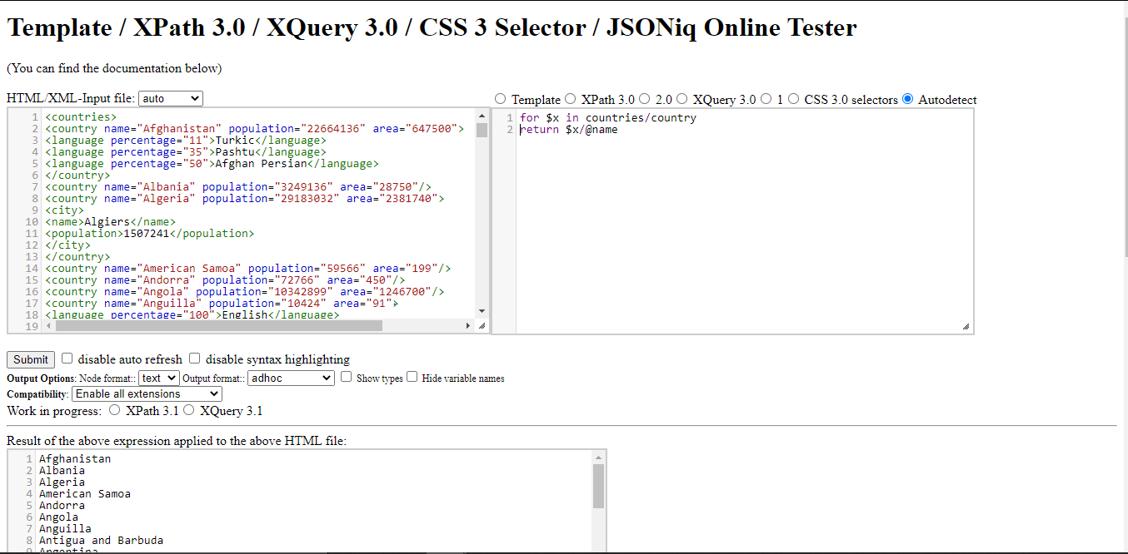

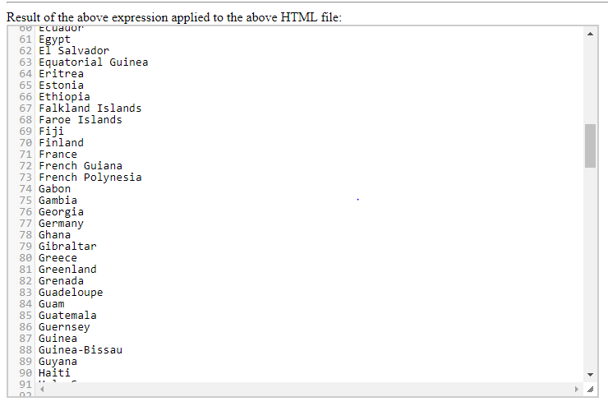

1. Return the name of the countries with population > 100 million

***Answer on the sample data:***

Bangladesh Brazil China India Indonesia Japan Nigeria Pakistan Russia United States

ANS:

for $x in countries/country

where $x /population>10000000

return $x/@name

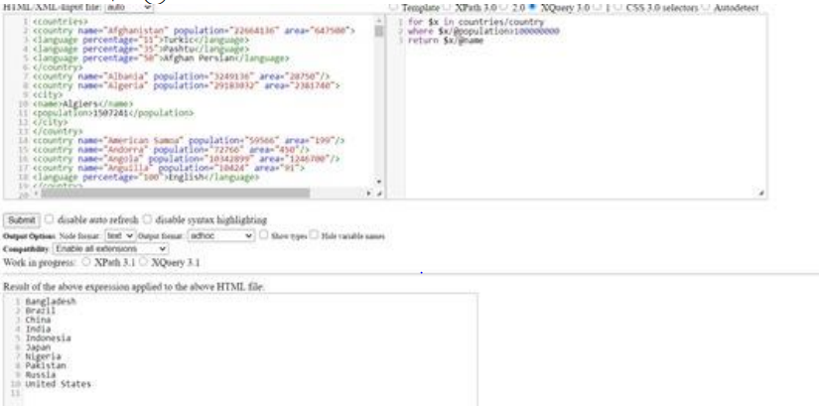

1. Return the country name and population for each country. For each country, combine the two pieces of information in a new element called <country_info>

***Start of the answer on the sample data:***

<country_info>Afghanistan, 22664136</country_info>

<country_info>Albania, 3249136</country_info>

<country_info>Algeria, 29183032</country_info>

<country_info>American Samoa, 59566</country_info>

<country_info>Andorra, 72766</country_info>

<country_info>Angola, 10342899</country_info>

ANS:

for $x in countries/country

return concat("<country_info>" , $x/@name, "," ,$x/@population,

"country_info>")

